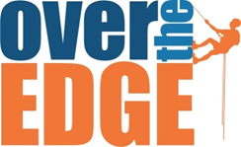

Credit Card Security Deposit Form
Please complete and return by May 4, 2018

In order to ensure my participation in Over the Edge on Saturday,
May 19, 2018, for Big Brothers Big Sisters of Southwest Virginia (BBBS), I hereby agree to allow BBBS to charge my credit card listed below in order to reach my fundraising minimum. I understand that by May 4th I must commit to raising the $1,000 minimum requirement to guarantee my spot. I understand that on May 4th if I am not at the fundraising minimum, the difference will be charged to my card and the maximum amount I may be charged is $1,000.

Please Accept My: □Visa □Mastercard □American Express

Name as it appears on card:______________________________________

Card Number:_______________________________________

Expiration Date:_____/_____ CVV# (3 digit code on back of card)_________

Billing Address:_________________________________________

City:__________________ State:________ Zip:_____________________

Work Phone:________________________

Home Phone:______________________________

Signature:______________________________________________

Date:__________________

This form must be received by April 16th
Please fax form to: 540-345-6992
Or scan and email form to:
jthoemke@bigslittles.org
Questions?
Contact: Josh Thoemke
540-798-0108

